Assignment – 3
- Create a webpage with a heading “Welcome to CSS” and use in line CSS to: Change the text color to blue, set a yellow background, and increase the font size to 30px.
Code:
<html>
<head>
<title>Q1</title>
</head>
<body>
<h1 style="color: blue; background-color: yellow; font-size: 30px;">
Welcome to CSS
</h1>
</body>
</html>
Output:

- Write a paragraph describing “Importance of CSS in Web Design”. Use internal CSS (<style> tag) to: Justify the text, Apply the font family Arial, Setlinespacing (line-height) to 1.6, Change font size to 18px.
Code:
<html>
<head>
<title>Q2</title>
<style type="text/css">
p {
text-align: justify;
font-family: Arial, sans-serif;
font-size: 18px;
line-height: 1.6;
}
</style>
</head>

<body>
<h1>Importance of CSS in Web Design</h1>
<p>
Cascading Style Sheets (CSS) is fundamental to modern web design because it separates a website's visual presentation from its structural content. By allowing developers to control layouts, typography, and color schemes independently of HTML, CSS ensures that websites are visually appealing and easy to maintain. CSS also helps in creating responsive designs that adapt to different screen sizes and improves user experience.
</p>
</body>
</html>
Output:
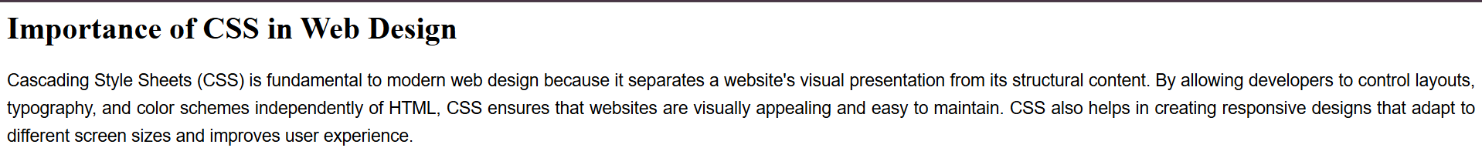
- Insert an image of your choice into the page. Create an external CSS file. Use a .photo-frame class to:
  - Set the image width to 300px.
  - Add a 5px solid blue border.
  - Add 10px margin around the image.
  - Add 15px padding inside the border.
Code:
Q3.html
<html>
<head>
<title>Q3</title>
<link rel="stylesheet" type="text/css" href="Q3.css">
</head>
<body>
<img src="download.avif" class="photo-frame">
</body>
</html>

Q3.css
.photo-frame {
width: 300px;
border: 5px solid blue;
margin: 10px;
padding: 15px;
}
Output:
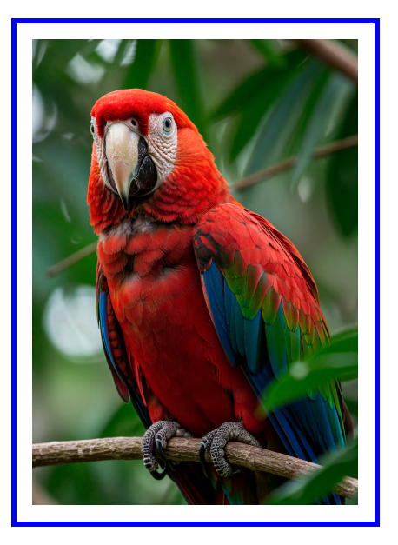
- Design a student mark sheet table with the following columns: RollNo, Name, Subject, Marks, Grade. Use external CSS to:
  - Add borders to the table, rows ,and cells.
  - Alternate row background colors (zebra striping).
  - Style the header row with a different background color and bold text.
  - Add padding in side table cells.
Code:
Q4.html
<html>
<head>
<title>Q4</title>
<link rel="stylesheet" type="text/css" href="Q4.css">
</head>
<body>
<table class="marks-table">
<caption><b>Student Mark Sheet</b></caption>
<tr>
<th>Roll No</th>
<th>Name</th>
<th>Subject</th>
<th>Marks</th>
<th>Grade</th>
</tr>
<tr>
<td>01</td>
<td>Abhishek</td>
<td>Math</td>
<td>93</td>
<td>O</td>
</tr>
<tr>
<td>02</td>
<td>Ishan</td>
<td>DAA</td>
<td>95</td>
<td>O</td>
</tr>
<tr>
<td>03</td>
<td>Surya</td>
<td>DBMS</td>
<td>85</td>
<td>E</td>
</tr>
<tr>
<td>04</td>
<td>Tilak</td>
<td>Python</td>
<td>95</td>
<td>O</td>
</tr>
<tr>
<td>05</td>
<td>Rahul</td>
<td>IT</td>
<td>84</td>
<td>E</td>
</tr>
</table>
</body>
</html>
Q4.css
.marks-table {
border-collapse: collapse;
width: 60%;
}
.marks-table,
.marks-table th,
.marks-table td {
border: 1px solid black;
padding: 10px;
text-align: center;
}
.marks-table th {
background-color: lightblue;
font-weight: bold;
}
.marks-table tr:nth-child(even) {
background-color: lightgrey;
}
Output:
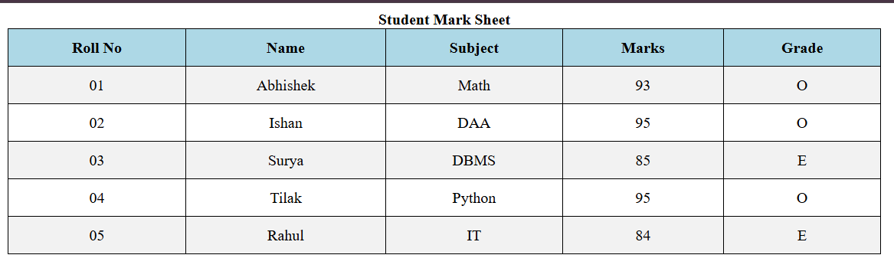
- Design the following Personal Profile Card using HTML and CSS.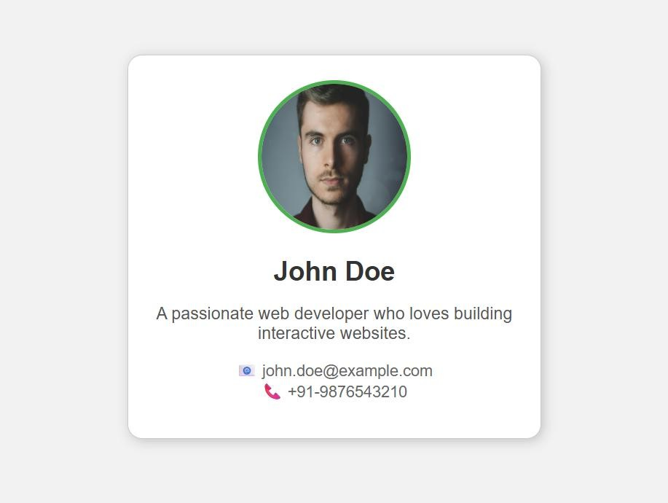
Code:
<!DOCTYPE html>
<html lang="en">
<head>
<meta charset="UTF-8">
<meta name="viewport" content="width=device-width, initial-scale=1.0">
<title>Personal Profile</title>
<link rel="stylesheet" href="Q5.css">
<link rel="stylesheet" href="https://cdnjs.cloudflare.com">
<link href="https://fonts.googleapis.com" rel="stylesheet">
</head>
<body>
<div class="profile-card">
<div class="profile-image-container">
<img src="C:\Users\SILICON\Documents\24BCSH03\Assignment 3\hitler.jpg" alt="John Doe" class="profile-img">
</div>
<div class="profile-details">
<h1 class="name">John Doe</h1>
<p class="bio">A passionate web developer who loves building interactive websites.</p>
<div class="contact-info">
<p><i class="fas fa-envelope icon"></i>✉ john.doe@example.com</p>
<p><i class="fas fa-phone icon"></i>📞 +91-9876543210</p>
</div>
</div>
</div>
</body>
</html>
Q5.CSS:
body {
display: flex;
justify-content: center;
align-items: center;
min-height: 100vh;
margin: 0;
background-color: #f0f2f5;
font-family: 'Poppins', sans-serif;
}
.profile-card {
background-color: #fff;
border-radius: 15px;
box-shadow: 0 4px 15px rgba(0, 0, 0, 0.1);
width: 350px;
padding: 30px 20px;
text-align: center;
transition: transform 0.3s ease-in-out;
}
.profile-card:hover {
transform: translateY(-10px);
}
.profile-image-container {
display: flex;
justify-content: center;
margin-bottom: 20px;
}
.profile-img {
width: 120px;
height: 120px;
border-radius: 50%;
object-fit: cover;
border: 4px solid green;
padding: 3px;
}
.name {
font-size: 1.8rem;
font-weight: 600;
margin: 0 0 10px;
color: #333;
}
.bio {
font-size: 0.9rem;
color: #666;
margin: 0 0 20px;
padding: 0 10px;
line-height: 1.4;
}
.contact-info p {
margin: 5px 0;
font-size: 0.85rem;
color: #444;
display: flex;
align-items: center;
justify-content: center;
}
.icon {
margin-right: 10px;
color: #4CAF50;
width: 15px;
text-align: center;
}
Output:


